
Enter Balancing Rays Presents Anti-Aging and Skin Care Biofeedback Training

Disclaimer

The information provided in this training document by Enter Balancing Rays is intended for educational and informational purposes only. It is not a substitute for professional medical advice, diagnosis, or treatment. The methods, protocols, and recommendations discussed are based on biofeedback and holistic approaches, and results may vary depending on individual circumstances.

By participating in this training or implementing the recommendations provided, you agree to assume full responsibility for your actions and outcomes. Enter Balancing Rays and its representatives are not liable for any direct, indirect, or consequential damage resulting from the use of the information presented.

1. Setting Up the Preset
- Create a New Preset:
  - Go to Setup in the Oberon system.
  - Click Create New Preset and name it appropriately, e.g., Anti-Aging Skin Care.
  - Ensure all previous selections are cleared by clicking Deselect All.
  - Verify the preset count is at zero before beginning.
  - Select Manual Choice the click on Store Checks to Current Preset.
    - A notification pops up to save select Yes.
- Adding Chromosomes and DNA:
  - Include relevant chromosomes and DNA strands for skin repair and anti-aging:
    - Chromosomes: 4, 6, 8, 12, 16, 20, X (for female) or Y (for male).
    - DNA Strands: Include all 16 relevant strands. (List and rationale provided in handouts.)
    - Tip: Copy and paste DNA strand identifiers carefully to avoid errors in the system.

2. Adding Body Areas
- Focus on Key Body Regions:
  - Include all skin-related areas, such as:
    - Scalp: Prevents sagging and supports circulation.
    - Facial Skin: Include upper lip, chin, and forehead for anti-wrinkle effects.
    - Feet: Addresses cracking and thickened skin.
    - Astrocytes: Supports inflammation control through the nervous system.
    - Thyroid: Ensures hormonal balance critical for skin health.
    - Adrenal Glands: Regulates stress hormones impacting skin repair.
    - Lymphatic System: Facilitates detoxification.
    - Liver: Essential for over 300 functions, including detox and skin repair.
    - Fibroblasts: Enhances skin elasticity and wrinkle reduction.
    - Endothelial and Epithelial Cells: Strengthen internal and external skin barriers.
    - Hemoglobin: Supports oxygen and nutrient delivery system-wide.

3. Scanning Within Specific Organs
- How to Scan Within Organs:
  - Navigate to the desired organ or region, e.g., Head → Facial Skin → Skin of the Upper Lip.
  - Hover over the thumbs to identify sub-regions like nerves, capillaries, or specific skin sections.
  - Click Scan Within to isolate data for specific sub-regions.
  - Add scanned regions to the preset automatically.
- Important Areas for Skin Care:
  - Facial Regions: Scan upper lip, chin, and scalp for specific wrinkle and elasticity treatments.
  - Body Regions: Include femur, pelvic region, and buttocks skin for cellulite and acne treatments.
  - Hemoglobin: Always include this for systemic support.

4. Adding Remedies
- Remedy Topics to Include:
  - Allopathy
  - Therapeutic Cosmetology
  - Q # Medicinal Cosmetics
  - BAA (Russia, NNPTSTO)
  - Health and Beauty Total
  - Cell-Com
  - Anti-Aging Table
- Selecting Remedies:
  - Use keyword searches such as “anti-aging,” “wrinkle,” “Botox,” “hydration,” “stretch marks,” or “cellulite.”
  - Focus on remedies with low dispersion (e.g., below 0.5) for optimal targeting.
  - For acne, add antibacterial, antiviral, antifungal, and anthelmintic remedies.
- Draw Count Recommendations:
  - Start with 4,500–8,000 for acute issues.
  - Adjust based on sensitivity and client response.

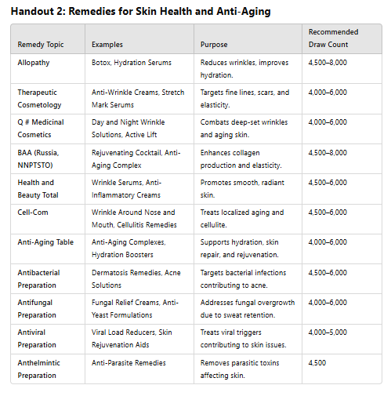

5. Running the Protocol
- Frequency:
  - For Acute Conditions: Run RF therapy 2–3 times daily for the first 3–4 days.
  - Maintenance: Use Meta Therapy 4–5 times per week.
- Monitoring Progress:
  - Re-scan key areas weekly to assess energy and KOD improvements.
  - Adjust remedies and regions as needed.

Handouts to Be Updated

1. Chromosomes and DNA Rationale
- Include a concise explanation of each included chromosome and DNA strand, emphasizing its role in skin health and anti-aging.
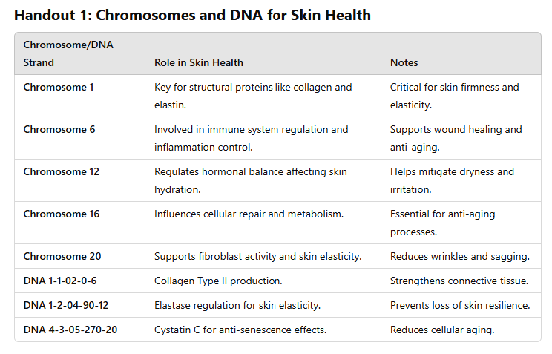

2. Remedy Selection
- Expand to include remedies specific to:
  - Anti-Wrinkle Treatments (e.g., Botox, collagen serums).
  - Acne Relief (antibacterial, antifungal, antiviral, and anthelmintic preparations).
  - Skin Elasticity (fibroblast-boosting remedies).

3. Specific Scans
- Provide visual guides for locating and scanning within:
  - Skin of the scalp, upper lip, and chin.
  - Pelvic region, buttocks, and femur for cellulite and acne.
  - Internal systems like hemoglobin, lymph nodes, and thyroid.
Case Study: Acne Therapy Using Meta Therapy and Remedies
Background:
- Client: 27-year-old female presenting with persistent acne primarily around the chin and lower facial region.
- History:
  - Acne flare-ups began in adolescence but have intensified in recent years.
  - Skin sensitivity to many over-the-counter acne treatments.
  - Recently experienced heightened breakouts with redness and inflammation.
  - Diet and stress levels are potential contributors.
Initial Scan and Findings:
- Facial Skin Scan (Chin Region):
  - Energy Level: Low (43%).
  - KOD: Below average, indicating poor nutrient delivery and potential inflammation.
  - Key Indicators:
    - Dermatosis (eczema or acne-prone skin).
    - Inflammation and blocked sebaceous glands.
- Additional Scans:
  - Hemoglobin: Moderate energy but signs of oxygen delivery issues to affected regions.
  - Nerves: Nerve bundles show mild inflammation, likely contributing to skin sensitivity.

Therapy Plan: Step-by-Step
1. Preparation
- Conduct a detailed skin scan focusing on:
  - Facial Skin (Chin Region): Map specific areas showing inflammation or poor energy.
  - Systemic Scans: Include hemoglobin and nerve bundles to assess contributing factors.
- Record energy and KOD levels before initiating therapy to track progress.

2. Meta Therapy Protocol
- Regions to Include:
  - Facial skin (chin region and adjacent areas).
  - Hemoglobin to improve oxygen and nutrient delivery.
  - Nerves to calm skin sensitivity and inflammation.
- Therapy Frequency:
  - Acute Phase: 2–3 sessions daily for the first 3–4 days.
  - Maintenance Phase: 4–5 sessions per week after initial improvement.

3. Remedies
- Remedy Topics to Use:
  - Allopathy Remedies:
    - Example: Dermatosis, Acne Remedies.
    - Suggested Draw Count: 4,500–5,000.
  - Therapeutic Cosmetology Remedies:
    - Example: Anti-wrinkle or anti-inflammatory creams (e.g., Botox, Hydration Serums).
    - Suggested Draw Count: 4,000.
  - Antibacterial Remedies:
    - Focus on combating bacterial contributions to acne (e.g., Antibacterial Creams).
    - Suggested Draw Count: 4,500.
- Keyword Search Tips for Remedies:
  - Use terms like acne, dermatosis, hydration, antibacterial to locate relevant remedies.
  - Select remedies with a low dispersion factor (below 0.5 preferred).

4. Application Methods
- Meta Therapy:
  - Apply RF therapy directly to the scanned facial regions (chin and lower face).
- Wearable Remedies:
  - Create a bracelet or necklace infused with selected remedies.
  - Suggested Draw Count: 4,500–8,000 depending on severity.
- Topical Application:
  - Infuse remedies into a non-perfumed base lotion (e.g., vaseline or nipple cream).
  - Apply directly to affected areas 2–3 times daily.

5. Monitoring Progress
- Re-scan the facial region every 3–4 days to track changes in energy and KOD levels.
- Note reductions in redness, inflammation, and acne lesions.
- Adjust therapy frequency and remedy selection based on improvement.

6. Client Education
- Lifestyle Recommendations:
  - Reduce inflammatory foods (e.g., sugar, processed foods).
  - Include skin-supportive nutrients (e.g., zinc, omega-3s).
  - Encourage hydration and stress management (e.g., yoga or meditation).
- Skincare Routine:
  - Use gentle, non-comedogenic products.
  - Avoid harsh exfoliants during active flare-ups.
  - Apply sunscreen to prevent hyperpigmentation.

Expected Results
- First Week: Reduction in inflammation and acne size with improved energy levels in the facial skin region.
- Weeks 2–4: Clearer skin with decreased redness and fewer breakouts.
- Long-Term: Maintenance therapy helps prevent future acne while improving overall skin health.

Case Study: Acne on the Back (Back Acne or “Bacne”)
Background:
- Client: 34-year-old male presenting with persistent acne on the upper back and shoulders.
- History:
  - Flare-ups triggered by excessive sweating and tight clothing.
  - Reports occasional itching and redness.
  - Previous treatments included over-the-counter salicylic acid washes with limited success.
Initial Scan and Findings:
- Skin of the Shoulders and Upper Back:
  - Energy Level: Low (38%).
  - KOD: Reduced, indicating inflammation and bacterial overgrowth.
  - Key Indicators:
    - Sebaceous gland blockages and dermatosis.
    - Potential fungal or bacterial involvement.
- Additional Scans:
  - Hemoglobin: Moderate energy, slight reduction in oxygen delivery to affected areas.
  - Microbiome Indicators: Presence of bacterial imbalances and potential fungal overgrowth.

Therapy Plan:
1. Preparation
- Conduct a detailed scan of:
  - Shoulder and Back Skin Regions.
  - Hemoglobin and Microbiome.
- Record energy and KOD levels for baseline tracking.
2. Meta Therapy Protocol
- Regions to Include:
  - Horizontal Cross-Section of Trunk at the Level of Shoulder joints
  - Hemoglobin for systemic support.
  - Capillaries and venules for oxygen and nutrient delivery.
- Therapy Frequency:
  - Acute Phase: 2–3 sessions daily for the first 5 days.
  - Maintenance Phase: 4 sessions weekly.
3. Remedies
- Remedy Topics:
  - Allopathy: Botox and other acne related remedies
  - Antibacterial Preparation: Target bacterial infections contributing to acne.
  - Antifungal Preparation: Address potential fungal overgrowth due to sweat retention.
  - Antiviral Preparation: For any underlying viral triggers.
  - Anthelmintic Preparation: To target potential parasitic contributions (less common but included preventatively).
  - Therapeutic Cosmetology: Include hydration and skin repair remedies.
- Example Remedies:
  - Dermatosis Preparations: For skin irritation and acne.
  - Botox and Anti-Wrinkle Creams: For skin smoothing and inflammation reduction.
- Draw Count Recommendations:
  - Start with 4,500 for acute conditions and increase to 6,000–8,000 if severe.
4. Application Methods
- Meta Therapy:
  - Focus on specific skin regions (shoulders, upper back).
  - Include systemic hemoglobin therapy.
- Wearable Remedies:
  - Infuse remedies into a necklace or bracelet for consistent exposure.
- Topical Application:
  - Mix remedies into a lotion or vaseline base for application after showers.
5. Monitoring Progress
- Re-scan affected regions every 5–7 days.
- Track reductions in acne lesions, redness, and inflammation.

Case Study: Acne on the Buttocks
Background:
- Client: 29-year-old female experiencing recurrent acne-like bumps on the back and buttocks area.
- History:
  - Primarily appears after prolonged sitting or workouts.
  - Skin is often dry and irritated, with occasional pustules.
Initial Scan and Findings:
- Skin of the Pelvic Region:
  - Energy Level: Low (42%).
  - KOD: Reduced, indicating poor circulation and clogged follicles.
  - Key Indicators:
    - Inflammation in sebaceous glands.
    - Dryness exacerbating follicular blockages.
- Additional Scans:
  - Lymph Nodes: Slightly congested, indicating suboptimal detoxification.
  - Capillaries: Low energy in localized regions, suggesting poor oxygen delivery.

Therapy Plan:
1. Preparation
- Conduct a detailed scan of:
  - Pelvic Skin and Gluteal Regions.
  - Lymphatic Nodes and Capillaries.
- Note specific areas with the lowest energy and KOD.
2. Meta Therapy Protocol
- Additional Thumbs to Include:
  - Skin of the pelvic and gluteal areas.
  - Nerves of the skin of the pelvic and gluteal areas.
  - Lymph nodes in the groin for detoxification.
  - Hemoglobin to improve circulation and healing.
- Therapy Frequency:
  - Acute Phase: 2 sessions daily for 5–7 days.
  - Maintenance Phase: 3–4 sessions weekly.
3. Remedies
- Remedy Topics:
  - Allopathy: Botox and other acne related remedies
  - Antibacterial Preparation: Target bacterial infections contributing to acne.
  - Antifungal Preparation: Address potential fungal overgrowth due to sweat retention.
  - Antiviral Preparation: For any underlying viral triggers.
  - Anthelmintic Preparation: To target potential parasitic contributions (less common but included preventatively).
  - Therapeutic Cosmetology: Include hydration and skin repair remedies.
- Example Remedies:
  - Hydration Serums: To restore moisture and prevent dryness.
  - Stretch Mark and Skin Smoothing Preparations: To improve texture.
- Draw Count Recommendations:
  - Begin with 4,000 and adjust to 6,000–8,000 for persistent issues.
4. Application Methods
- Meta Therapy:
  - Target the pelvic and gluteal regions with focus on lymphatic support.
- Topical Application:
  - Use remedies in a fragrance-free lotion for daily use after workouts or showers.
5. Monitoring Progress
- Monitor changes in lesion size, redness, and skin texture.
- Adjust frequency based on healing progress and client feedback.

