
Oberon Step by Step Guide Digestion and Natural Remedies
Enhancing Digestive Health Through Biofeedback and Natural Remedies

Disclaimer

The information provided in this training document by Enter Balancing Rays is intended for educational and informational purposes only. It is not a substitute for professional medical advice, diagnosis, or treatment. The methods, protocols, and recommendations discussed are based on biofeedback and holistic approaches, and results may vary depending on individual circumstances.

By participating in this training or implementing the recommendations provided, you agree to assume full responsibility for your actions and outcomes. Enter Balancing Rays and its representatives are not liable for any direct, indirect, or consequential damage resulting from the use of the information presented.
I. Introduction
- Overview of the digestive system and its significance in overall health.
- Introduction to biofeedback and its application in digestive health.
II. Gallbladder Health
- Summary of the provided article on gallbladder function and wellness.
- Discussion on the role of the gallbladder in digestion, including bile production and fat metabolism.
- Natural remedies and lifestyle modifications to support gallbladder health.
- Article on gallbladder health: Gallbladder Health / Quantum Science Wellness | Enter Balancing Rays
III. Anatomical Focus Areas in Biofeedback Therapy
Detailed overview of digestive system components to be covered:
- Esophagus: Highlighting the therapy focus on its brown image section (Oberon visual aid).
- Wall of the Stomach: Role in digestion and therapy points.
- Duodenum: First section of the small intestine and its importance.
- Intestine: General function and specific therapy points for optimization.
- Intestine Wall: Supporting nutrient absorption and motility.
- Twisted Intestine: Addressing misalignments or blockages.
- Colon: Importance in water absorption and waste removal.
- Rectum and Sphincter: Therapy for elimination support and prevention of discomfort.

Please see the table on the next screen
Digestive Area | Function | Therapy Focus in Biofeedback | Visual/Notes
Esophagus | Transfers food from mouth to stomach. | Focus on the brown image section to enhance smooth muscle function. | 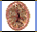
Wall of the Stomach | Produces digestive juices and absorbs nutrients. | Therapy to balance acidity and improve enzyme function. | -
Duodenum | Initiates absorption of nutrients. | Balance bile release and nutrient uptake. | -
Intestine | Breaks down food for nutrient absorption. | Therapy for motility and microbial balance. | -
Intestine Wall | Supports nutrient absorption and immunity. | Strengthen epithelial integrity. | -
Twisted Intestine | May hinder nutrient absorption and digestion. | Correct blockages and align motility. | -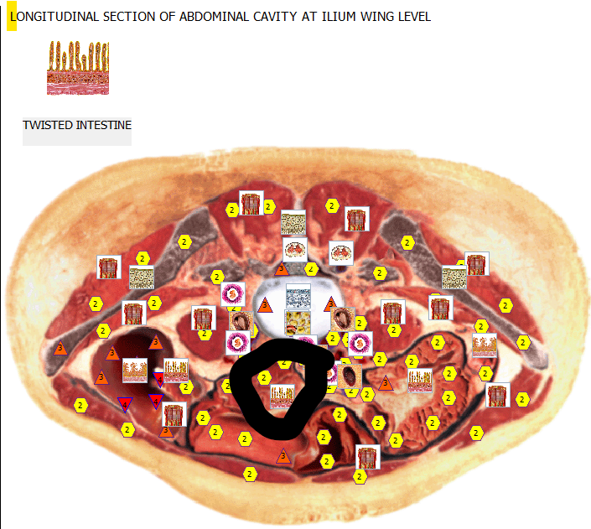
Colon | Absorbs water and electrolytes. | Improve transit time and detoxification. | -
Rectum | Stores waste for elimination. | Relieve pressure and inflammation. | -
Sphincter | Controls bowel movements. | Strengthen and relax for comfort. | -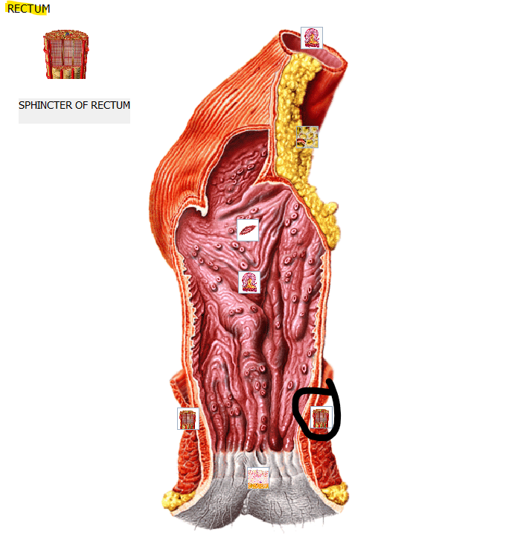
Liver | Produces bile, processes nutrients, and detoxifies. | Support bile production and detox pathways.
Lymphatic System (Stomach) | Supports immune function and drainage in the digestive tract. | Stimulate lymphatic flow to reduce bloating and improve detox. | -

IV. Nervous and Lymphatic System Connections
- Exploration of the nervous system's interaction with the stomach and its impact on digestion.
- Analysis of the lymphatic system's role in digestive health.
V. Genetic Considerations in Digestive Health
- Introduction to relevant DNA components that may influence digestion:
  - Lipoma Collagen Type 2 (Osteo Skeletal/Digestion).
  - Elastase 1/Synaptobrevin.
  - Elastin/Serine (Endocrine/Sensory/Digestion).
  - Pancreatic Acinus cells and their role in enzyme production.
  - Arginase of Liver Immune Interferon Receptor.
  - Lissencephaly Gene 2/Fatty Acids Connecting Protein of Liver (Digestive System/5th Chromosome/Endocrine).
  - Actinic Insular Cells of Pancreas and their function in hormone synthesis.
- Discussion on chromosomes associated with digestive functions, including recent findings on the Y chromosome's impact on digestive diseases.

DNA and Chromosome Y and X Table for Digestive Health
Sequence | DNA/Chromosome Component | Role in Digestion | Rationale for Therapy
DNA 1 - 1 - 08 - 0 - 12 | Lipoma Collagen Type 2 (Osteo Skeletal/Digestion) | Supports structural integrity of digestive tissues and skeletal framework. | Enhancing collagen synthesis can strengthen connective tissues in the digestive tract, improving motility and resilience to stress or injury.
DNA 1 - 2 - 04 - 90 - 12 | Elastase 1/Synaptobrevine (Elastin/Serine) | Key for maintaining elasticity in digestive tissues and regulating digestive enzyme activity. | Therapy targeting this DNA aids in improving elasticity in digestive organs like the intestines and enhances enzyme activity, facilitating better nutrient absorption.
DNA 1 - 2 - 04 - 90 - 12 (Endocrine/Sensory/Digestion) | Elastin/Serine | Integral in the sensory feedback loop and digestive signaling pathways. | Supporting elastin production helps maintain the flexibility of the digestive tract and optimizes sensory and endocrine interactions, particularly for stress-related digestive issues.
Pancreatic Acinus | Acinar Cells | Exocrine cells responsible for producing digestive enzymes transported to the duodenum. | Therapy focuses on enhancing enzyme secretion to improve the breakdown of proteins, fats, and carbohydrates, essential for efficient digestion and nutrient absorption.
DNA 1 - 2 - 15 - 270 - 6 | Arginase of Liver Immune Interferon Receptor | Facilitates nitrogen metabolism and immune signaling in liver and digestive systems. | Promotes the liver’s ability to process waste products from digestion while supporting immune response to gut pathogens, reducing inflammation.
DNA 1 - 2 - 11 - 270 - 2 | Lissencephaly Gene 2/Fatty Acids Connecting Protein of Liver | Regulates fatty acid transport and processing, critical for liver and digestive health. | Enhancing fatty acid metabolism improves energy availability and reduces fat accumulation in the liver, supporting overall digestive efficiency and preventing fatty liver disease.
DNA 1 - 2 - 11 - 270 - 2 A | Cells of Pancreatic Islets | Regulate blood glucose levels and secrete hormones that influence digestion. | Therapy improves hormonal balance (e.g., insulin and glucagon), which directly impacts glucose metabolism and digestive enzyme secretion, enhancing overall digestive health.
DNA 1 - 2 - 11 - 270 - 2 A | Actinic Insular Cells of Pancreas | Synthesize and secrete both digestive enzymes and hormones like insulin and glucagon. | Enhancing these cells supports dual functionality in breaking down food and maintaining blood sugar levels, a critical factor for preventing disorders like diabetes and pancreatitis.
Chromosome Y and X | Influence on Digestive Diseases | Regulates specific genes affecting inflammation, immune responses, and stress adaptations in the gut. | Recent findings highlight the Y chromosome’s role in managing gut microbiota and regulating immune responses, offering targeted therapeutic pathways for addressing inflammation-related digestive diseases, particularly in males.

Explanation of Components
- DNA Sequences: The sequences represent unique identifiers for genes or cellular components, specifying their location and function in the digestive system.
- Chromosome Y Role: Recent research indicates that genes on the Y chromosome influence gut health through inflammation control and microbiota regulation, making it a novel focus in digestive therapy.
- Therapeutic Applications: Each entry includes the rationale for how targeted therapy through biofeedback and frequency remedies can enhance digestive system performance and manage related disorders.
VI. Practical Application
- Case studies demonstrating biofeedback therapy applied to digestive health issues.
- Interactive session with biofeedback equipment focusing on the digestive system.
VII. Conclusion
- Recap of key points covered in the training.
- Q&A session to address participant queries.

