
Oberon Recommended Customizations

- Adding the Description Column to the Remedy Selection Panel
- To search by keyword in the remedy selection panel, click the asterisk on the left of the panel headings.
  - Select the description filter on the second column of check boxes
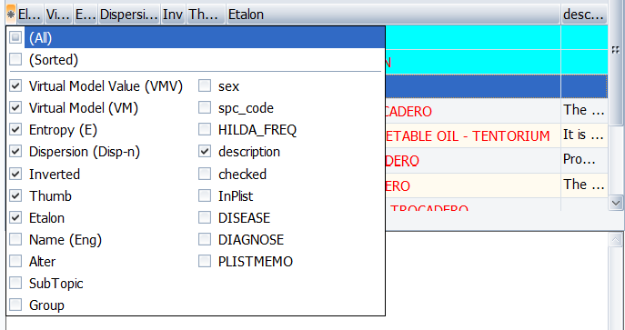
  - Once added, you will need to adjust the formatting to view the remedies.
    - Go to the Oranopreparat topic select and then select the SHOW ALL tab.
    - Gray dividers on the left side of the remedy selection panel separate each row. Hover your mouse over the thin line between remedy rows until the cursor changes to an up-and-down arrow.
    - Left click and drag your mouse up to the top of the screen.
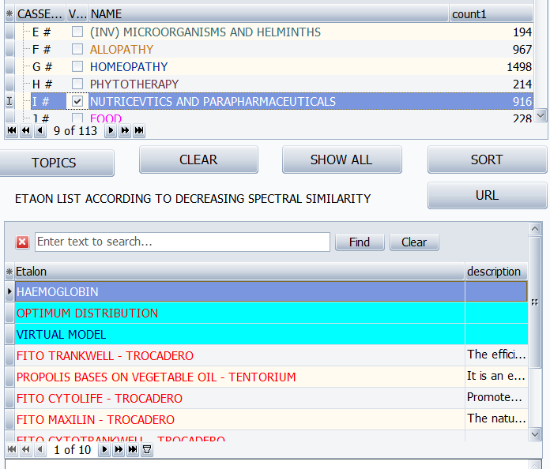
Mouse curser will appear like this when formatting is enabled
- Accessing the Topics Tab
  - In the Analysis page, click on the Topics tab, located on the left middle section of the page. This will open a comprehensive list of available remedy topic groups.

- Topics Count
  - To verify if a topic includes remedies, click on the asterisk symbol (*) to the left of the column heading CASSETTE.
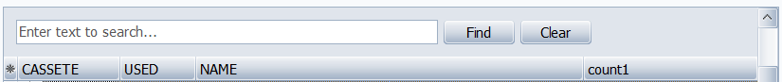
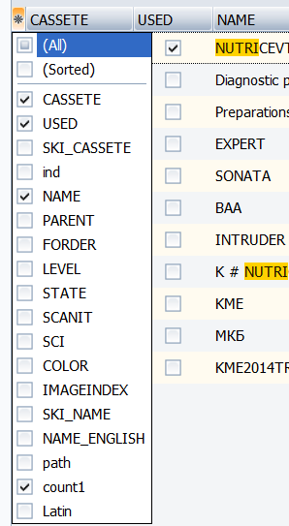
  - From the menu that appears, select Count (second to the last on the list). This will display the remedy count next to each topic name, indicating whether remedies are associated with that topic.
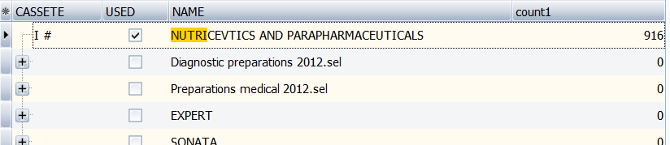
    - This will ensure there are remedies within the topics you are selecting.
- Expanding Topic Groupings (In the Topics tab)
  - If the desired topic is not found in the search results, follow these steps:
  - To further explore topic groupings, right click in the gray area above the column headings, and select Expand. This will display all the topics within each grouping for easier selection.
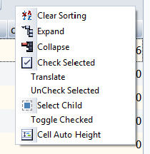
- Selecting and Adding Topics
  - Scroll through the expanded list to locate the specific topics you want to add to the Analysis Page.
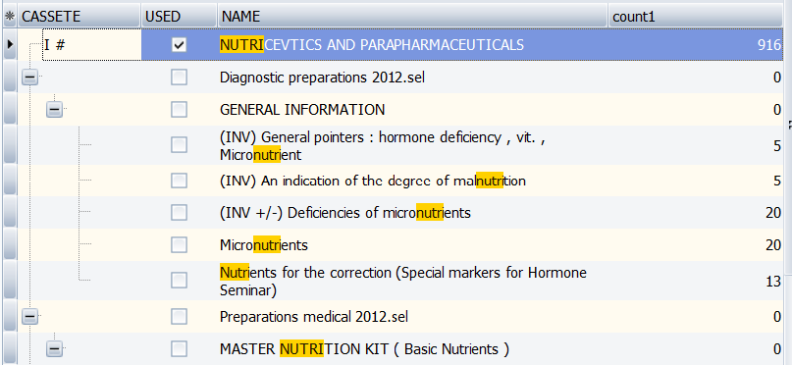
  - When you’ve selected all desired topics, click Exit at the top-right corner of the Topics page to return to the main Analysis page.
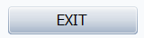
Confirming the Topics Added in the Analysis Page
- Searching for Added Topics on the Analysis Page
  - On the Analysis page, use the search bar at the top left to enter the names of the topics you’ve added. This will allow you to quickly access and work on these topics.
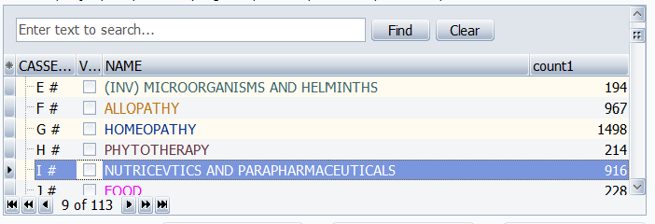
- Topics Count (On the Analysis Page)
  - To verify if a topic includes remedies, click on the asterisk symbol (*) to the left of the column heading CASSETTE.
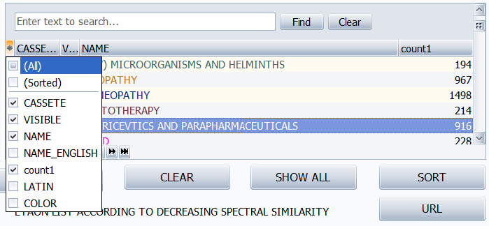
  - From the menu that appears, select Count (third to the last on the list). This will display the remedy count next to each topic name, indicating whether remedies are associated with that topic.
    - This will ensure there are remedies within the topics (if the count is 0 then there are no remedies available to select).

