
Comprehensive Biofeedback Practitioner Training Guide
(Provided by Enter Balancing Rays)

Disclaimer
This training from Enter Balancing Rays is for educational and entertainment purposes only. It does not provide medical advice and is not intended to diagnose, treat, or cure any condition. Use of this information is at your own discretion and risk.

1. Client Engagement: Delivering Value in the First Session
The goal is to deliver clear value in the first session to establish trust and build long-term engagement.
A. Preparation and Rapport
- Review Client Files: Read the consent and questionnaire (including name, age, history, and primary concerns).
  - Example electronic Client Consent form: https://www.enter-balancing-rays.com/contact/client-intake-form
  - Example Client Questionnaire: https://www.enter-balancing-rays.com/contact/client-questionnaire
  - All information on the website examples was created from the Oberon office forms located on page 140 of Oberon’s updated user manual.
- Environment Setup: Ensure the software and hardware (e.g., scan system, headset) are functional. Prepare a clean, quiet space.
- Warm Welcome: Greet the client using their name, and share your excitement about the technology and what they may gain from the session.
- Ease and Understanding: Reassure them this is a discovery process, not a medical diagnosis. Ask, “What guided you to book this session today?”
B. The Scan, Review, and Takeaways
- Conduct the Scan: Create the client card and launch the full body scan.
  - Review the scan details:
    - On the left side of the page shows the graph we are identifying system imbalances each graph point shows either a system or systems that cross. When the RED line crosses over the blue it shows possible chronic imbalances.
    - On the bottom of the right side of the page shows a shape of optimization of the organ/tissue/cell light colored shapes number 1 – 2 show an optimal balance. The darker the shapes become shows less optimization.
    - Above the image displays the name of the organ/tissue/cell.
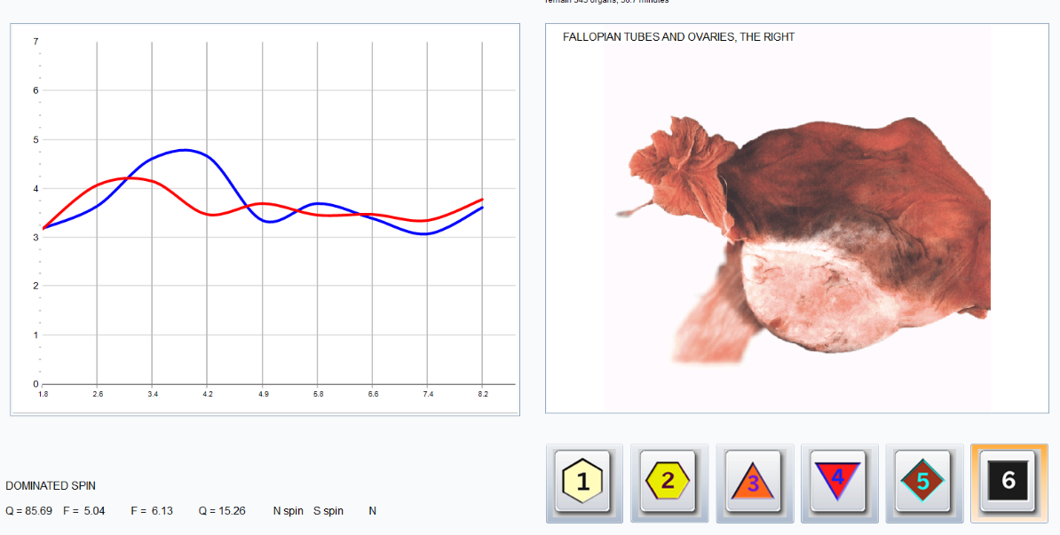
    - At the top right of the page shows how many organs remain to be scanned and the time remaining for the scan.

- Present Data Simply and Time Efficient: Use Report 8 to review key findings. Explain major indicators (toxins, nutrients, microbiology) using simple terms.
  - Example: “Your nutrient levels are a bit low, toxins are elevated, and your microbiology system is out of balance.”
- Offer Quick Wins: Share 2–3 actionable suggestions such as a foot soaks, hydration, breathing techniques before eating, gentle stretching, or energy movements. Keep it simple and cost-free where possible.
  - If you provide the client with information that they can use immediately – nutrient deficiencies, natural detox methods, reflexology and breathing techniques usually the client will continue services or refer a client to you in the future.
  - If the client seems excited and thanks you for the information and service ask for a referral and provide them with a place on your website or an email sharing their experience to build your businesses creditability.
- Hour Consultation: If you are only scheduling an hour for the consultation (recommended to keep the client engaged utilize the 3rd page of report and the food avoidance information found on page 14.

C. Setting Expectations and Retention Strategy
- What Comes Next: Explain that follow-up sessions may include deeper analysis and personalized remedy selection.
- Present Continued Options: Offer monthly check-ins, frequency therapy packages, or remote support options.
- Confirm Interest: Ask, “Would you like me to send you the therapy estimate along with your report?”
  - Creating a therapy plan estimate: see attachment for prompting Chat GPT or LM Notebook to create a professional therapy plan estimate.
- Timely Follow-Up: Within 24–48 hours, send a summary email with observations, recommendations, and next steps.
  - Advanced Reporting & Data Interpretation – see attachment for prompting Chat GPT or LM Notebook to create professional reports.

2. Marketing, Niche Selection, and Ethical Practices
A. Niche Focus & Online Presence
- Choose a Specialty: Areas may include Pathology and Microbiology, Aura and Chakras, Pet Health, or Emotion and Relationship therapy.
- Digital Presence: Create a website with disclaimers and easy contact. Use free tools like Canva, ChatGPT, and Ideogram for marketing content.
- Local Promotion: Offer free scans to local wellness business owners (e.g., yoga studios, supplement shops).
B. Highlighting Core Modalities
Modality | Purpose & Highlights | Client Benefit
Meta-Correction Therapy | Non-invasive training down to cellular level; includes remedy preparation. | System optimization and balance.
Aura Scan | Visual scan of energy fields via analysis page; optional visual/music therapy. | Detects vibrational imbalances; visual affirmation for clients.
Chakra Therapy | Scan and correct the 7 chakras (Search: “Chakras”). | Emotional stabilization and energy flow.
Crystal & Stone Therapy | Uses vibrational data from stones (Search: “Stone”) via reprinter/device. | Emotional resilience, grounding, and clarity.
Phytotherapy | Energetic therapy for detox, immune, or systemic support. | Enhances remedy impact and gentle support.
Emotional State Support | Invert trauma, fear, shame or promote balance (peace, clarity, etc.). | Regulates emotion and supports generational healing.

3. Business Protection and Credibility
Trust and professionalism are rooted in clarity, ethical boundaries, and organized systems.
A. Establishing Credibility
- Display Credentials: Share your training or system experience where appropriate.
- Communicate Clearly: Avoid jargon; explain what you do and don’t do.
- Set Boundaries: “I do not diagnose or treat any medical condition.”
- Stay Consistent: Deliver reports on time and maintain professional communication.
- Educate Clients: Provide FAQs, explain what biofeedback is, and offer supportive literature.
B. Legal & Operational Protection
- Client Consent: Use clear digital consent forms with privacy and data policies.
- Website Disclaimers: Your site must include Terms, Conditions, and Scope of Practice.
- Insurance: Secure Errors & Omissions (E&O) insurance to protect your practice.
  - See attachment for full details
- Keep Records: Document session dates, services provided, and communication history.

4. Business Foundation and Compliance
For U.S.-based practitioners, establish your legal and financial footing with these essentials:
- Choose a Business Structure: LLC is recommended for liability protection and flexibility.
- Apply for EIN: Free and instant at irs.gov/ein.
- U.S. Sales Tax: Most U.S. states require sales tax registration if you're selling physical products (e.g., creams, supplements, printed reports) or operating in a state where digital goods are taxable. Check your state’s Department of Revenue for specific requirements.
- International Clients & VAT: If you work with clients in the European Union (EU) or United Kingdom, you may be required to register for Value-Added Tax (VAT) if your annual revenue from those regions exceeds a specific threshold.
  - Use the EU’s One-Stop-Shop (OSS) or UK VAT registration portal to manage your obligations.
  - VAT typically applies to digital products (like PDFs, video courses, remote software-based services), not live consultations—but check local laws.
  - Consider using platforms like Stripe Tax or Quaderno to automate VAT collection and compliance.
- Business County Tax: Apply through your county tax collector.
- Business Bank Account: Open with your EIN and LLC documents.
- File Taxes: Use TurboTax Business or a CPA, especially if you have multiple income sources or significant deductions.
  - See attachment for full details

A. Ethical Communication
- Do Not Diagnose or Treat: Be clear and cautious with your language.
- Avoid Terms Like: Cancer, Cure, Pain Relief, or Treatment.
- Reference Protocols: Follow Oberon Biofeedback Association guidelines when unsure.
- Offer Scans First: If a client is hesitant, suggest just the scan, report review, and simple suggestions. Invite them back in 4–8 weeks.

